# 1、angularJs的路由控制

## 解释：只有访问带#的地址才能有页面js也就是样式等

## 1、比如要进入http://localhost:8080/healerjean 页面就查看list分页

### 1、controller ，地址栏中输入上面的地址首先进入的就是healerjean.ftl 模板页面

@Controller  
@RequestMapping("healerjean")  
@ResourceFolder(folder = "module/healerjean/")  
public class HealerJeanController {  
  
   
  
  
 @RequestMapping("")  
 @ResourceAppend  
 public String index(){  
 return "healerjean.ftl";  
 }  
  
@RequestMapping("list")  
 @ResourceAppend  
 public String list(){  
 return "healerjean_list.ftl";  
 }

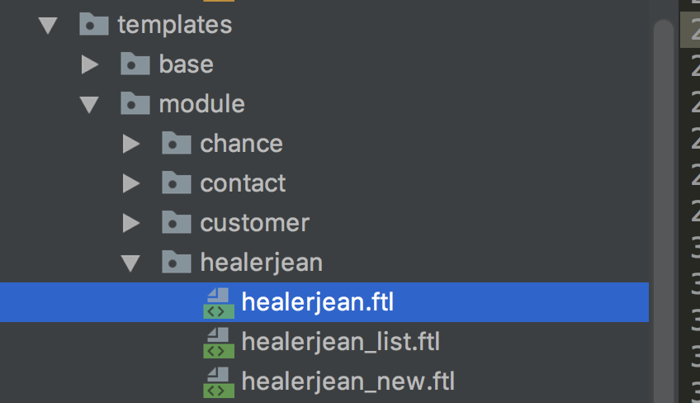

## 2、healerjean.ftl 内容如下 ng-app的定义和自定义标签的定义，用来存放其他的模板页面，也就是说，其他的list new页面 其实全部是在这这个section中 ng-view就是路由控制

<!DOCTYPE html>  
<html>  
<head>  
 <title>CRM管理</title>  
<#include "../../base/resource.ftl">  
  
*<#-- moment -->* <script src="${urls.getForLookupPath('/assets/js/plugins/moment/moment.min.js')}"></script>  
*<#--<script src="${urls.getForLookupPath('/assets/js/plugins/moment/moment.zh-CN.js')}"></script>-->  
  
<#-- datepicker -->* <link rel="stylesheet" type="text/css" href="${urls.getForLookupPath('/assets/js/angularjs/datetimepicker/css/datetimepicker.css')}"/>  
 <script src="${urls.getForLookupPath('/assets/js/angularjs/datetimepicker/js/datetimepicker.js')}"></script>  
 <script src="${urls.getForLookupPath('/assets/js/angularjs/datetimepicker/js/datetimepicker.templates.js')}"></script>  
  
*<#-- daterangepicker -->* <link rel="stylesheet" type="text/css" href="https://admore-cas.oss-cn-hangzhou.aliyuncs.com/common/js/angularjs/daterangepicker/daterangepicker.css"/>  
 <script src="${urls.getForLookupPath('/assets/js/angularjs/daterangepicker/daterangepicker.js')}"></script>  
 <script src="${urls.getForLookupPath('/assets/js/angularjs/daterangepicker/angular-daterangepicker.js')}"></script>  
  
*<#-- ui select -->* <link rel="stylesheet" type="text/css" href="${urls.getForLookupPath('/assets/js/angularjs/uiselect/css/select.min.css')}"/>  
 <script type="text/javascript" src="${urls.getForLookupPath('/assets/js/angularjs/uiselect/js/select.min.js')}"></script>  
  
*<#--bigbang -->* <link rel="stylesheet" type="text/css" href="${urls.getForLookupPath('/assets/js/plugins/bigbang/css.css')}"/>  
 <script type="text/javascript" src="${urls.getForLookupPath('/assets/js/plugins/bigbang/pirobox.js')}"></script>  
  
 <script type="text/javascript" src="${urls.getForLookupPath('/assets/js/plugins/photo/jquery.photo.gallery.js')}"></script>  
  
  
*<#-- 引入本实例需要0的js -->* <script src="${urls.getForLookupPath('/ftl/module/healerjean/js/init.js')}"></script>  
 <script src="${urls.getForLookupPath('/ftl/module/healerjean/js/HealerJeanController.js')}"></script> //分页的js  
 <script src="${urls.getForLookupPath('/ftl/module/healerjean/js/HealerJeanNewController.js')}"></script>// 添加和修改的js  
  
</head>  
<body class="sidebar-mini skin-black-light">  
  
<div class="content-wrapper fixed layout-row" ng-app="app">  
 <section class="content toggle flex no-toolbar" ng-view>  
  
 </section>  
</div>  
</body>  
<style>  
  
</style>  
</html>

<#assign ctx=Request.request.getContextPath()>  
<link rel="icon" href="https://admore-cas.oss-cn-hangzhou.aliyuncs.com/assets/img/common/favicon.png" type="image/x-icon">  
<link rel="shortcut icon" href="https://admore-cas.oss-cn-hangzhou.aliyuncs.com/assets/img/common/favicon_green.png" type="image/x-icon">  
<meta charset="utf-8">  
<meta name="renderer" content="webkit|ie-stand">  
<meta http-equiv="X-UA-Compatible" content="IE=edge,chrome=1">  
  
<script type="text/javascript">  
 var ***ctx*** = ***window***.ctx = "${ctx}";  
 var ***oss_host*** = "${oss_host}";  
</script>

## 3、打开 init.js 也就是初始化的js

### 解释：当访问http://localhost:8080/healerjean时，下面的when中没有对应的路径，但是在.otherwise 中具备，所以会到了/list中，也就是开始加载 模板ctx +'/healerjean/list，此时浏览器中地址变为http://localhost:8080/healerjean#/list

var ***app*** = angular.module('app',['ngAnimate'  
 ,'ngRoute'  
 ,"ngDialog"  
 ,"ngMessages"  
 ,"httpPostFix"  
 ,'ui.bootstrap.datetimepicker'  
 ,"ui.select"  
 ,"ngSanitize"  
 ,"angularFileUpload"  
 ,'ui.bootstrap.datetimepicker'  
 ,'isteven-multi-select'  
 ,"daterangepicker"  
]);  
/**  
 * 1、路由控制器 ，给模板页面提供js  
 */  
***app***.config(['$routeProvider', function($routeProvider) {  
 $routeProvider  
 .when('/list', {  
 templateUrl: ***ctx*** +'/healerjean/list',  
 controller:'HealerJeanController'  
 })  
 .when('/new', {  
 templateUrl: ***ctx*** +'/healerjean/new',  
 controller:'HealerJeanNewController'  
 })  
  
 .when('/new/:id', {  
 templateUrl: ***ctx*** +'/healerjean/new',  
 controller:'HealerJeanNewController'  
 })  
  
 // .when('/new/:id', {  
 // templateUrl: function(){  
 // return ctx +'/healerjean/new/';  
 // },  
 // controller:'HealerJeanNewController'  
 // })  
 .otherwise({  
 redirectTo: '/list'  
 });  
}]);

# 2、分页展示数据（异步的请求）

## 1、js中直接请求

var ***HealerJeanController*** = app.controller('HealerJeanController', function($rootScope,$scope,$http,$location,ngDialog) {  
  
 /**  
 * 1、初始化数据  
 */  
 $scope.pageResult = {};  
 $scope.query = {};  
  
  
 /**  
 *2、 请求得到 数据字典  
 */  
 $http.get(***ctx*** + '/healerjean/map')  
 .success(function(data, status) {  
 $scope.typeList = data;  
 })  
 .error(function(data, status) {  
 ngDialog.alert('查询失败');  
 });  
  
 /**  
 * 3、分页函数  
 * @param pageNow  
 */  
 $scope.getData=function (pageNow) {  
 $scope.query.pageNow = pageNow;  
 $http.post(***ctx*** + '/healerjean/listGetPage',$scope.query) //hibernate分页  
 .success(function(data, status) {  
 $scope.pageResult = data;  
 })  
 .error(function(data, status) {  
 ngDialog.alert('查询失败');  
 });  
 }  
  
  
  
 /**  
 * 4、数据字典选择 赋值  
 * @param key  
 * @param value  
 */  
 $scope.chooseType=function (key,value) {  
 $scope.query.pactType = key;  
 $scope.typeName=value;  
 }  
  
 /**  
 * 5、新建联系人页面  
 */  
 $scope.newContact=function () {  
 $location.path("new");  
 };  
  
 /**  
 * 6、页面数据展示  
 */  
 $scope.getData(0);  
  
  
 /**  
 * 7、根据id删除记录  
 * @param id  
 */  
 $scope.deleteById=function (id) {  
 $http.get(***ctx*** + '/healerjean/deleteById',{  
 params: { "id":id}  
 }).success(function(data,header,config,status) {  
 $scope.getData(0);  
 }).error(function(data,header,config,status) {  
 $scope.getData(0);  
  
 });  
 }  
  
 /**  
 * 8、进入 控制器 编辑页面，在js中传递参数 id  
 * @param id  
 */  
 $scope.edit=function (id) {  
 //# 表示去控制器中进行查找路径，否则就会到url Java controller中找路径  
 //window.location.href="/healerjean#/new?id="+id;  
 //***window***.location.href="/healerjean#/new/"+id;  
  
 $location.path("/new/"+id);  
 }  
  
 /**  
 * 9、上下一页分页  
 */  
  
 $scope.getPageJumpData=function (pageNow) {  
 $scope.query.pageNow = pageNow;  
 $http.post(***ctx*** + '/healerjean/listGetPage',$scope.query) //hibernate分页  
 .success(function(data, status) {  
 $scope.pageResult = data;  
 $scope.query.pageSize=$scope.pageResult.size;  
 })  
 .error(function(data, status) {  
 ngDialog.alert('查询失败');  
 });  
 }  
  
});

## 2、页面中model的数据绑定

<#assign ctx=Request.request.getContextPath()>  
  
  
<div class="center-content">  
 <div class="base-list emax-base-list">  
 <div class="title">联系记录</div>  
 <div class="search">  
 <div class="flex-between-center">  
 *<#--<div date-range-picker class="btn btn-default configDobleTime" type="button" ng-model="adDate" options="adOpts" required>-->  
 <#--{{adDate.startDateStr}}<i class="adLineStyle">-</i>{{adDate.endDateStr}}-->  
 <#--<span class="caret"></span>-->  
 <#--</div>-->* <div class="flex-wrap">  
 <div class="dropdown adDropdown">  
 <input type="text" ng-model="query.customerName" class="condition" neme="customerName" placeholder="客户信息查询">  
 </div>  
 <div class="dropdown adDropdown">  
 <button class="btn btn-default dropdown-toggle multi-select flex-around-center" style="width: 130px;" type="button" id="dropdownMenu1" data-toggle="dropdown" aria-haspopup="true" aria-expanded="true">  
 {{***typeName***}}  
 <span class="caret"></span>  
 </button>  
 <ul class="dropdown-menu" aria-labelledby="dropdownMenu1">  
 *<#--<li ng-repeat="item in typeList"><a ng-click="chooseType(item)">{{item.label}}</a></li>-->* <li ng-repeat="(key,value) in typeList"><a ng-click="chooseType(key,value)">{{***value***}}</a></li>  
  
 </ul>  
 </div>  
 <button class="btn btn-default btn-search" ng-click="getData(0)">查询</button>  
 </div>  
 <button class="btn-primary pull-right" ng-click="newContact()">新建</button>  
 *<#--<button class="btn-primary pull-right" data-toggle="modal" data-target="#new-customer">新建</button>-->* </div>  
 </div>  
 <table class="table margin-top-3">  
 <thead>  
 <tr>  
 <th>创建时间</th>  
 <th>主题</th>  
 <th>客户</th>  
 <th>联系人</th>  
 <th>客户类型</th>  
 <th>客户时间</th>  
 <th>联系内容</th>  
 <th>创建人</th>  
 <th>操作</th>  
 </tr>  
 </thead>  
 <tbody>  
 <tr ng-repeat="item in pageResult.content">  
 <td ng-bind="item.addTime|date:'yyyy-MM-dd: HH:mm'"></td>  
 <td ng-bind="item.subject"></td>  
 <td ng-bind="item.customerName"></td>  
 <td ng-bind="item.connect"></td>  
 <td ng-bind="item.pactType"></td>  
 <td ng-bind="item.connectTime|date:'yyyy-MM-dd HH:mm'"></td>  
 <td ng-bind="item.content"></td>  
 <td ng-bind="item.creator"></td>  
 <td>  
 <a ng-click="edit(item.id)">编辑</a>  
 <span class="text-explode">|</span>  
 <a ng-model="id" ng-click="deleteById(item.id)" >删除</a>  
 </td>  
 </tr>  
 </tbody>  
 </table>  
 <div class="footStyleIn">  
 <div></div>  
 <div class="footRightPageStyle">  
 <div class="footPageDisplayInfo">共有{{***pageResult***.totalElements}}条，&nbsp;每页显示：<paged num="2"></paged></div>  
 <pager page="{{***pageResult***.number}}" total-pages="{{***pageResult***.totalPages}}" click-method="getPageJumpData"></pager>  
 </div>  
 </div>  
 </div>  
</div>  
  
<div class="modal fade" id="new-customer" style="display: none;">  
 <div class="modal-dialog" style="width: 750px;">  
 <div class="modal-content">  
 <div class="modal-header flex-between-center">  
 <h4>客户联系信息</h4>  
 <button type="button" class="close" data-dismiss="modal" aria-label="Close">  
 <span aria-hidden="true">×</span></button>  
 </div>  
 <div class="modal-body">  
 asdjkf  
 </div>  
 <div class="modal-footer">  
 <button type="button" class="btn btn-default pull-right" data-dismiss="modal">关闭</button>  
 </div>  
 </div>  
 </div>  
</div>  
  
  
<style>  
 .search .btn.btn-search{margin: 20px 20px 0 0;}  
  
 .right-sidebar .down {width: auto;}  
 .center-content .base-list .search .condition{width: 280px;background: none;padding-left: 5px;}  
</style>

# 3、添加数据

## 1、js添加数据

var ***HealerJeanNewController*** = app.controller('HealerJeanNewController', function($rootScope,$scope,$http,$location,ngDialog, $routeParams,FileUploader) {  
  
  
 $scope.save=function () {  
 $http.post(***ctx*** + '/healerjean/add',$scope.target) //hibernate分页  
 .success(function(data, status) {  
  
 toastr.success('保存联系记录信息成功','提示');  
 ngDialog.alert('添加成功');  
 $location.path("/healerjean#/list").replace();  
 })  
 .error(function(data, status) {  
 ngDialog.alert('添加失败');  
 });  
 }

# 2、js添加数据页面

<#assign ctx=Request.request.getContextPath()>  
  
<div class="center-content">  
 <div class="application-form emax-base-list">  
 <div class="form-frame">  
 <div class="title">维护联系记录  
 <a class="btn btn-toinstlist btn-xs margin-left-2" ng-click="backContact()"><span class="adBackIcon">返回联系记录列表</span></a>  
 </div>  
 <div class="second-btn-tab display-block">  
 <div class="form-list">  
 <div class="form-item form-remark">  
 <div class="item-title">主题</div>  
 <input name="subject" ng-model="target.subject" type="text" class="item-select" placeholder="请填写联系目的">  
 </div>  
 <div class="form-divider"></div>  
 <div class="form-item flex-col-center">  
 <div class="item-title">联系日期</div>  
 <div class="dropdown">  
 <a class="dropdown-toggle startDate" data-toggle="dropdown">  
 <div class="input-group">  
 <input type="text" name="connectTime" class="item-select target-date text-center" ng-model="target.connectTime|date:'yyyy-MM-dd'" readonly />  
 </div>  
 </a>  
 <ul class="dropdown-menu" role="menu">  
 <datetimepicker data-ng-model="target.connectTime" datetimepicker-config="{ dropdownSelector: '.startDate', minView:'day',modelType:'YYYY-MM-DD' }"/>  
 </ul>  
 </div>  
 </div>  
 <div class="form-divider"></div>  
 <div class="form-item flex-col-center">  
 <div class="item-title">客户</div>  
 <div class="select-wrap adManager">  
 <div  
 isteven-multi-select  
 input-model="customerList"  
 output-model="outputModelTypeModel.outputData"  
 button-label="label"  
 item-label="label"  
 tick-property="checked"  
 search-property="label"  
 translation="localLang"  
 helper-elements="all none filter"  
 output-properties="value label"  
 max-height="200px"  
 selection-mode="single"  
 >  
 </div>  
 </div>  
 </div>  
 <div class="form-divider"></div>  
 <div class="form-item flex-col-center">  
 <div class="item-title">客户类型</div>  
 <div class="item-radio ad-flex">  
 <div class="radio-info checked">  
 <input id="radio_item1" type="radio" class="input-radio" name="pactType" value="1" ng-model="target.pactType" checked="checked">  
 <label for="radio_item1"></label>  
 <span>实地拜访</span>  
 </div>  
 <div class="radio-info">  
 <input id="radio_item2" type="radio" class="input-radio" value="2" name="pactType" ng-model="target.pactType">  
 <label for="radio_item2"></label>  
 <span>电话联系</span>  
 </div>  
 <div class="radio-info">  
 <input id="radio_item3" type="radio" class="input-radio" value="3" name="pactType" ng-model="target.pactType">  
 <label for="radio_item3"></label>  
 <span>邮件</span>  
 </div>  
 <div class="radio-info">  
 <input id="radio_item4" type="radio" class="input-radio" value="4" name="pactType" ng-model="target.pactType">  
 <label for="radio_item4"></label>  
 <span>微信</span>  
 </div>  
 </div>  
 </div>  
 <div class="form-divider"></div>  
 <div class="form-item form-remark">  
 <div class="item-title">联系人</div>  
 <input name="connect" ng-model="target.connect" type="text" class="item-select" placeholder="请填写联系人">  
 </div>  
 <div class="form-divider"></div>  
 <div class="form-item form-remark">  
 <div class="item-title">内容</div>  
 <div class="item-remark">  
 <textarea name="content" class="textarea-remark" ng-model="target.content" onfocus="if(***value***=='200字以内'){value=''}" onblur="if (***value*** ==''){value='200字以内'}">200字以内</textarea>  
 </div>  
 </div>  
 <div class="form-divider"></div>  
 <div class="form-item flex-col-center">  
 <div class="item-title">附件</div>  
 <div>  
 <div class="flex-col-center" ng-class="{'margin-top-2':$index>0}" ng-repeat="attach in attachs track by $index">  
 <input type="hidden" ng-model="attach.attachPic"/>  
 <div class="item-upload" ng-click="selectFile($index)" ng-disabled="uploading">  
 {{attach.btnText}}  
 <input type="file" nv-file-select class="upload-file" uploader="uploader">  
 </div>  
 <img class="margin-left" ng-src="${oss_host}/{{attach.attachPic}}" style="height: 45px;" ng-if="attach.attachPic!=undefined && attach.attachPic!=''">  
 <div class="upload-des" ng-if="$index!=0"><a class="btn btn-default btn-xs" ng-click="removeTargetAttachs($index)"><i class="glyphicon glyphicon-trash"></i></a></div>  
 </div>  
 <div class="upload-des margin-top-2 no-margin">仅支持 JPG/PNG 图片文件，且上传图片需<10M</div>  
 <div class="form-group col-sm-12 text-center margin-top-2">  
 <a class="btn btn-default btn-sm" ng-click="addTargetAttachs()"><i class="glyphicon glyphicon-plus" ></i></a>  
 </div>  
 </div>  
 </div>  
 <div class="form-item flex-col-center">  
 <div class="item-title"></div>  
 <div class="form-button">  
 <button class="btn-primary" ng-click="save()">保存</button>  
 <button class="btn-primary disabled margin-left-3" ng-click="backContact()">取消</button>  
 </div>  
 </div>  
 </div>  
 </div>  
  
 </div>  
 </div>  
</div>  
  
<script type="application/javascript">  
 $(***document***).ready(function () {  
 $(".radio-info").on("click",function(){  
 if($(this).hasClass("radio-info")){  
 $(this).siblings(".radio-info").each(function () {  
 $(this).removeClass("checked");  
 $(this).children("input[type='radio']").removeAttr("checked")  
 });  
 $(this).addClass("checked");  
 $(this).children("input[type='radio']").prop("checked","checked")  
 }  
 });  
 })  
</script>  
  
<style>  
  
  
</style>

# 3、更新（重中之重）

因为，这个主要是通过ng-view路由自定义的模板，并且通过路由控制器来控制模板页面的js的，如果如果直接传参数到java 代码controller中，再返回页面，这样就再需要添加一个update页面了，因为直接使用add页面会因为传来的数据为空值而报错。即使添加了u-pdate页面，contrller 直接返回的页面，会因为ng-view路由控制器中没有地址对应的js控制器而造成js代码缺失，丢失页面属性。

## 正确的方法是，采用angularJs提供的路由传递参数，相当于是js跳转接收参数

### 1、编辑按钮添加点击事件

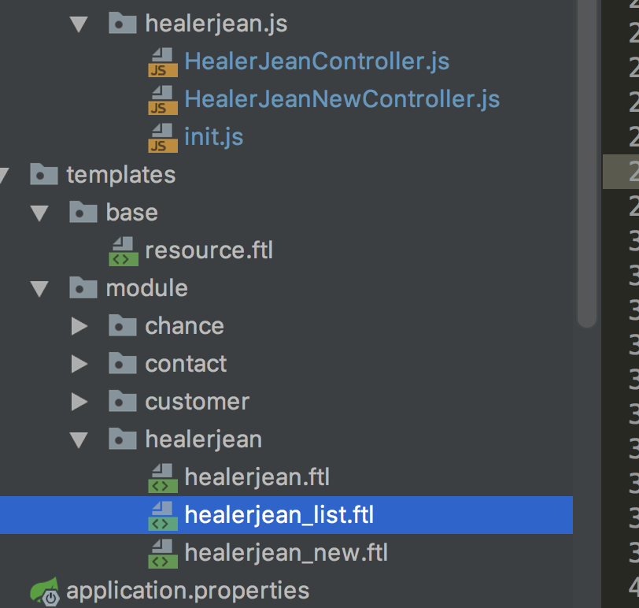

<td>  
 <a ng-click="edit(item.id)">编辑</a>  
 <span class="text-explode">|</span>  
 <a ng-model="id" ng-click="deleteById(item.id)" >删除</a>  
</td>

### 2、js中捕获id并进行调转页面

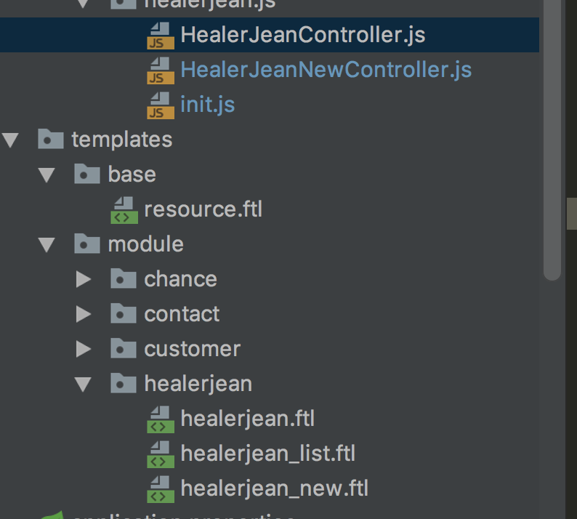

#### 1、：$location.path 代表的是#后面的地址 比如 http://localhost:8080/healerjean#/new/16

/**  
 * 8、进入 控制器 编辑页面，在js中传递参数 id   
 * @param id  
 */  
$scope.edit=function (id) {  
  
 $location.path("/new/"+id);  
}

### 3、路由控制器匹配url

#### 1、.when('/new/:id' 表示参数将为id，路由参数将来可以直接获取

#### 2、这里需要注意的是 update和add是使用的同一个模板页面，控制器我这里也用了同一个

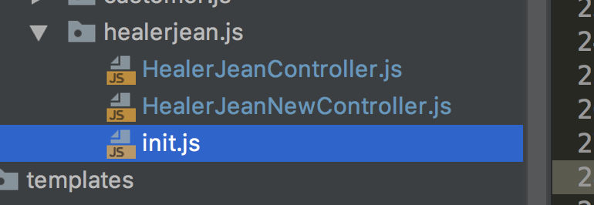

/**  
 * 1、路由控制器 ，给模板页面提供js  
 */  
***app***.config(['$routeProvider', function($routeProvider) {  
 $routeProvider  
 .when('/list', {  
 templateUrl: ***ctx*** +'/healerjean/list',  
 controller:'HealerJeanController'  
 })  
 .when('/new', {  
 templateUrl: ***ctx*** +'/healerjean/new',  
 controller:'HealerJeanNewController'  
 })  
  
 .when('/new/:id', {  
 templateUrl: ***ctx*** +'/healerjean/new',  
 controller:'HealerJeanNewController'  
 })  
.otherwise({  
 redirectTo: '/list'  
 });  
}]);

### 4、接收路由提供者提供的参数，

#### 解释： 后台传来的数据包括date日期传过来就会变成时间戳，如果后台直接使用对象接收的话，会报错。因为类型不匹配，所以前台需要什么给什么数据就行了，像汉中updatetime等的那种数据没有必要传过来

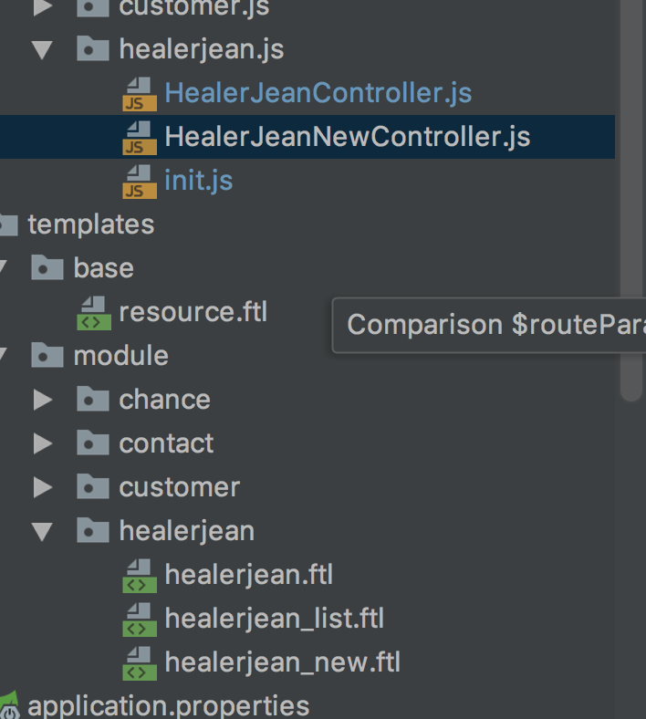

var ***HealerJeanNewController*** = app.controller('HealerJeanNewController', function($rootScope,$scope,$http,$location,ngDialog, $routeParams,FileUploader) {  
  
  
   
  
 /**  
 * 2、从路由参数中取出数据id，然后通过异步的方式请求java controller，获取根据id查找的数据  
 */  
 if($routeParams.id != undefined){  
 $http.get(***ctx*** + '/healerjean/findHealerJeanById?id='+ $routeParams.id)  
 .success(function(data, status) {  
 if(data!=null){  
 $scope.target.id = data.id;  
 $scope.target.subject = data.subject;  
 $scope.target.connectTime = data.connectTime;  
 $scope.target.pactType = data.pactType;  
 $scope.target.connect = data.connect;  
 $scope.target.content = data.content;  
 } else {  
 ngDialog.alert("查询id失败");  
 }  
 })  
 .error(function(data, status) {  
 ngDialog.alert('加载联系记录信息失败');  
 });  
 }

### 5、补充

#### 1、利用windos.location.herf请求控制器页面

$scope.edit=function (id) {  
 //# 表示去控制器中进行查找路径，否则就会到url Java controller中找路径  
 ***window***.location.href="/healerjean#/new?id="+id;  
 http://localhost:8080/healerjean#/new?id=16  
}

$scope.edit=function (id) {  
 //# 表示去控制器中进行查找路径，否则就会到url Java controller中找路径  
   
 ***window***.location.href="/healerjean#/new/"+id;  
  
 http://localhost:8080/healerjean#/new/16  
}

#### 2、模板使用函数加载

.when('/new/:id', {  
 templateUrl: function(){  
 return ***ctx*** +'/healerjean/new/';  
 },  
 controller:'HealerJeanNewController'  
})

#### 3、解释：其实不管是 /id 还是id=? 其实主要还是控制器中所控制的：id那样，是不是有点像@pathvalueable。

### 6、解释：

#### 1、# 表示走的是js路由控制器地址